**Task 1:   
  
Dataset**: AdventureWorksCustomers.xlsx  
**Question**:  
Ensure correct data types:

* CustomerID → Text
* BirthDate → Date

Answer:-  
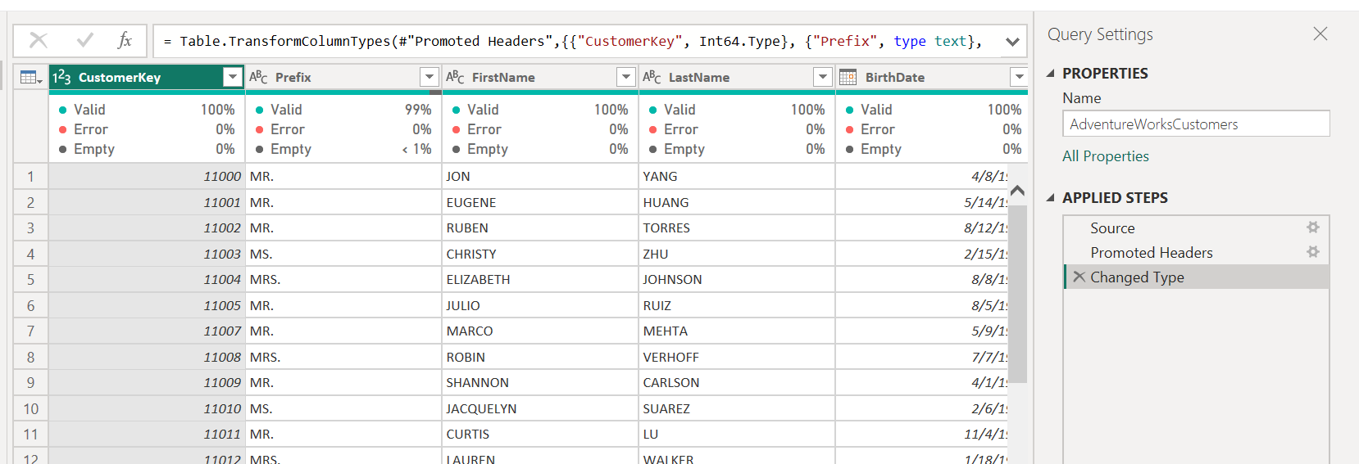  
  
Steps to change the data types.  
  
1.select the column, which we want to change the data type.  
2. Go to TRANSFORM RIBBON and select the DATA TYPE.  
3. CustomerID to Text,

4.BrithDate to Date.  
  
Just displaying the output.

**Task 2: Replace Values**

**Dataset**: AdventureWorksProducts.xlsx  
**Question**:  
Replace all "Bike" entries with "Bicycle" in the ProductName column.  
Answer :-  
  
Before:  
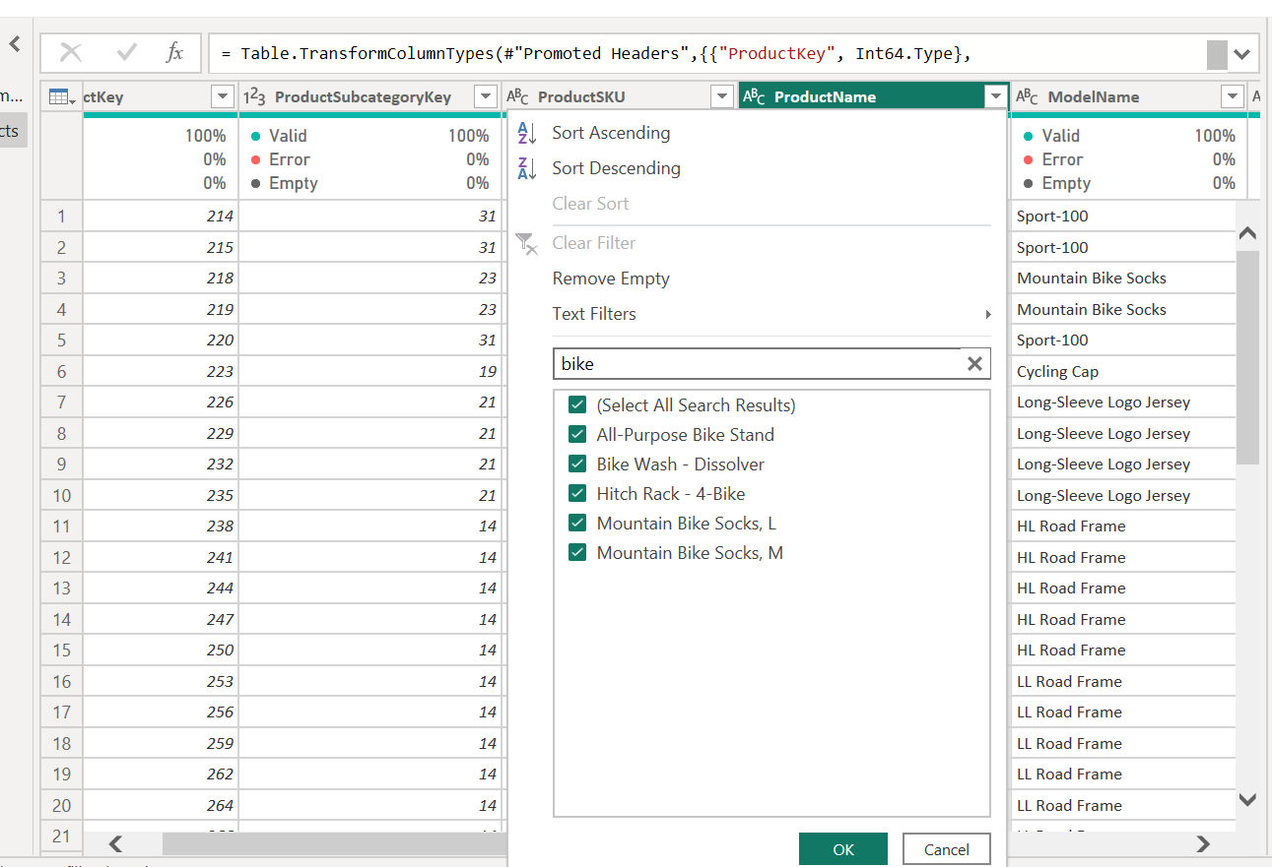  
  
Please find the lighted once, still data is not changed.  
How to change the data   
steps  
1.Go to transform ribbon.  
2.select the REPLACE VALUE.  
2.1 Give the old value to new value.  
  
final output:

**Task 3: Pivot Column**

**Dataset**: Combined Sales2015-2017 (includes Year column)  
**Question**:  
Pivot Year column to create separate columns for each year showing **total OrderQty** per CustomerID.  
  
Answer:  
Using Append function. I can append the table first.

**Task 4:**

**Dataset**: AdventureWorksCustomers.xlsx  
**Question**:  
Split FullName into FirstName and LastName.

Using split with delimiter.

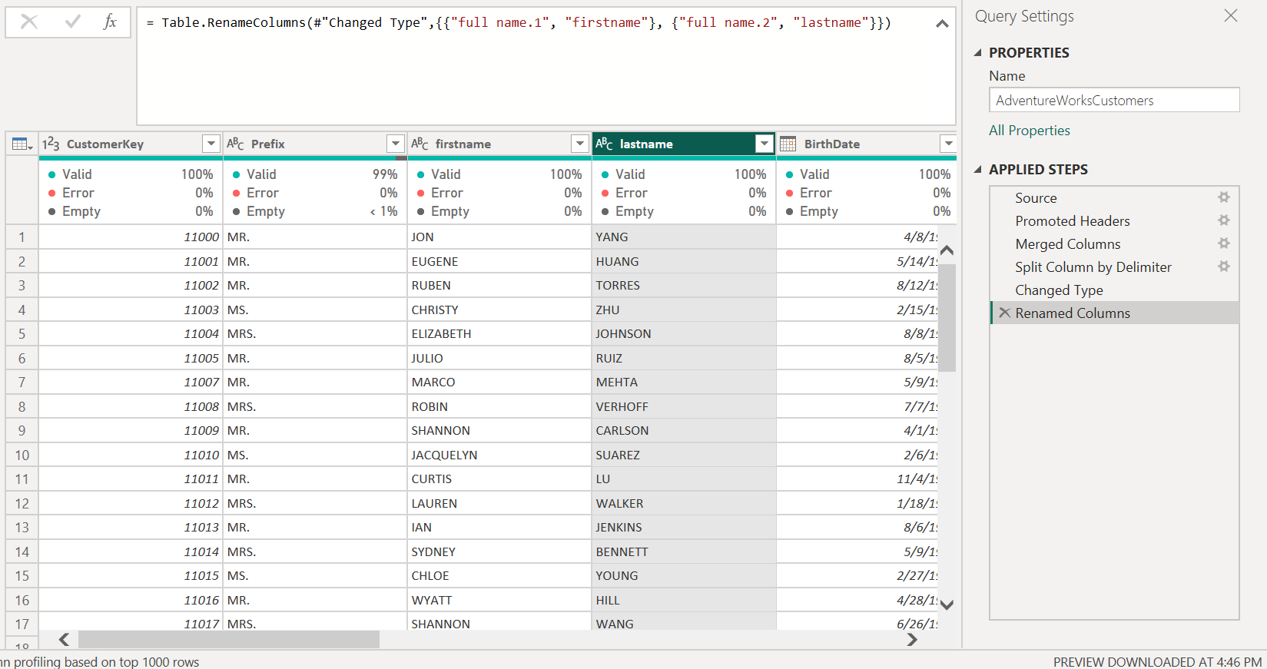

**Task 7:**

**Dataset**: AdventureWorksCustomers.xlsx  
**Question**:  
Clean the Email column:

* Convert to lowercase
* Trim spaces

Before converting data.

Final output

**Task 6:**

**Dataset**: AdventureWorksCustomers.xlsx  
**Question**:  
Merge FirstName and LastName into FullName with space as a separator.

Using merged column  
  
Before:  
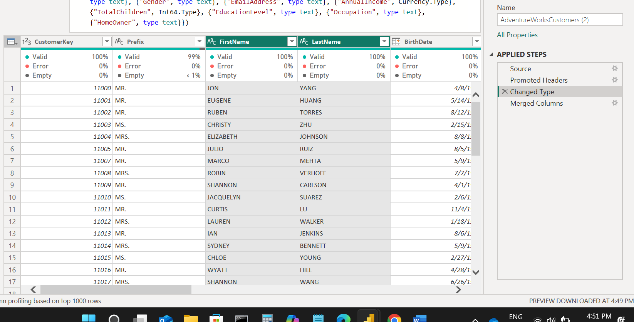

Final output

